Sales Forecasting RESULTS
- Distribution of Sales
This plot clearly shows the highly right-skewed nature of your sales data and the presence of many zero sales and high-value outliers. It's crucial for understanding the data's inherent challenges.
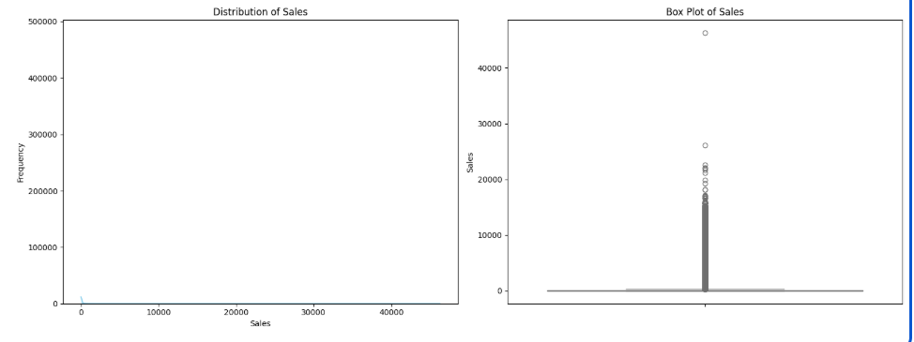
- Average Sales by Store Number and Product Family
These bar plots effectively illustrate how sales vary across different stores and product categories, highlighting top performers and potential areas for focus.
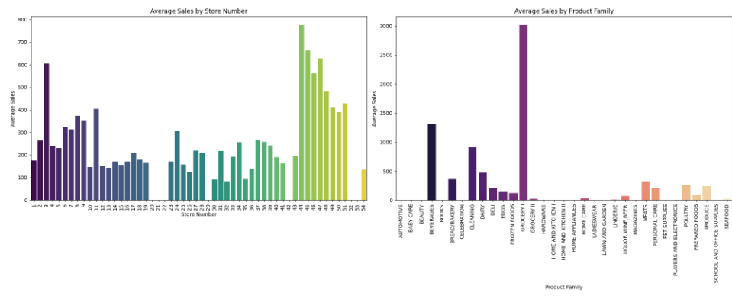
- Total Sales Over Time
This line plot demonstrates the overall trend and strong seasonality in your sales data, which are key characteristics of the time series.
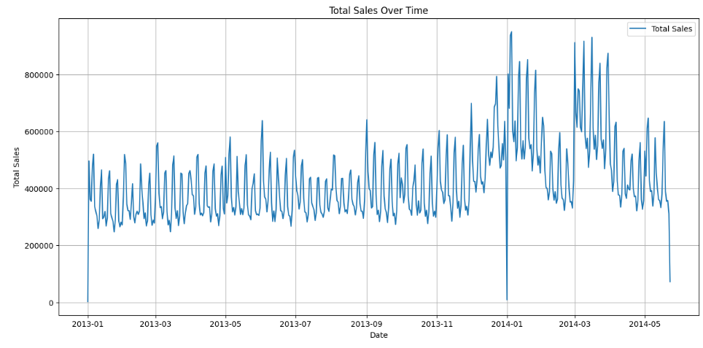
- ARIMA Model Forecast vs. Actual Sales
This is vital for showing how your ARIMA model performed on unseen data during the evaluation phase. It visually represents the Root Mean Squared Error (RMSE) and the model's ability (or inability) to capture fluctuations.
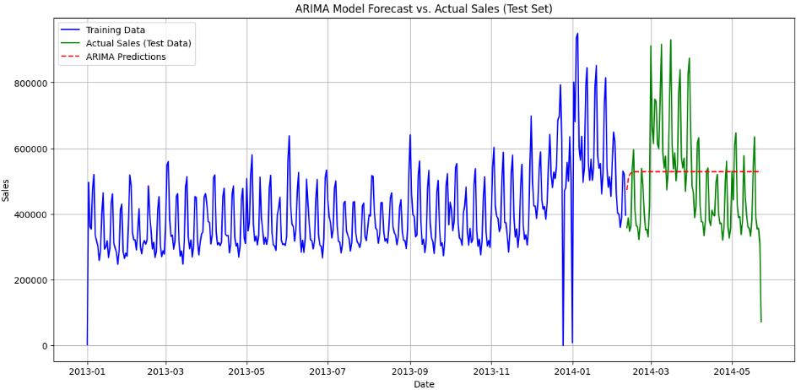
- ARIMA Model Forecast vs. Historical Sales with Confidence Interval
This plot showcases your model's future sales predictions along with their uncertainty (confidence intervals), giving a clear picture of the forecast.
